

Kneading 4 Health & Relaxation
Mobile Massage
2121 North Webb Road, Suite 204
Grand Island, NE 68803
(308)380-5494

Name: ________________________________________________________________
Last First
D.O. B _______/______/__________ ( MM / DD / YYYY )
Occupation: ____________________________________________________________
Home Address: _________________________________________________________
City ________________________ State: ____________ Zip: ____________________
Cell Phone #: ___________________________ Email: _________________________
Home Phone #: ____________________________ Business #: ___________________
Referred by: _ __________________________________________________________
Emergency Contact: ________________________Phone:________________________
Have you ever had a professional massage before? Yes ( ) No ( )
Do you have any difficulty lying on your front, back or side? Yes ( ) No ( )
Are you allergic to Latex or vinyl or nut products? Yes ( ) No ( )
Any known allergies and or sensitivities to topical applications? Yes ( ) No ( )

Do you have or have you had any of the following conditions?
Check appropriate lines.
___Allergies ___Arthritis ___Cancer, _____________
___Depression ___Diabetes ___Dizziness
___Epilepsy ___Fibromyalgia ___Head Aches
___Heart Attack ___Heart disease ___High Blood Pressure
___Low Back Pain ___Multiple Sclerosis ___Neck Pain
___Nervousness ___Numbness ___Polio
___Poor Circulation ___Shoulder Pain ___Skin Problems _________
___Stroke ___Tuberculosis ___Ulcers, type __________
___Varicose Veins ___Edema (swelling) ___Lumps in Breast/chest
___Menopausal Symptoms ___Premenstrual Syndrome ___Pregnant – weeks ______
___Digestive Issues ___Constipation ___Alcohol/Drug Dependency
___Stiff Neck ___Recent Surgery ________ ___Whiplash
___Fractures ___Recent Fever ___Any Contagious Disease
___Inflammation ___Insomnia ___ Other ________________
___HIV virus ___ Decreased ROM
Any further comments or information regarding your health history that would be useful for your massage therapist to know? _______________________________________________ __________________________________________________________________________

Are you presently under the care of a physician? Yes ( ) No ( ) if yes, please explain: ______
__________________________________________________________________________
Are you taking any medications? Yes ( ) No ( )
Are you currently taking any antibiotics? Yes ( ) No ( )
If so please list any prescription & non-prescription medications, vitamin or mineral supplements or other remedies that you are taking and what they are prescribed for? _______________________________________________________________________
Circle areas of concern on the diagram below:

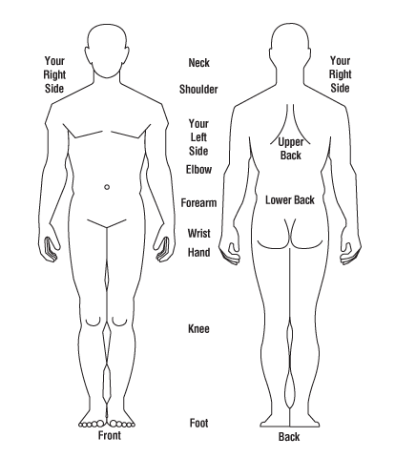
1. What type of pressure do you prefer?
Light / Medium /Firm
(Extra Charge -Firm)

2. Table heated: Yes/No

3. Would you like a Young Living essential oil
added to your massage? Yes/No
(Single $5 Combo $10)

4. Spend more time on these areas: ______________________________________

5. Stay away from these areas: ______________________________________

POLICIES
Draping will be used during the session. Only the area being worked on will be uncovered.

- I understand that: 24 hours notice is required for cancellation. Initial ______
- I understand my therapist will be using non-latex gloves for infection control. Initial _____
- I will ensure that all animals are not present in the room during home/mobile massage session. Initial ____
d.) I understand services outside of GI, additional charges per mile will apply. Initial _____

I, ____________________________________ (print your name) understand that the massage I
receive is provided for the basic purpose of relaxation and relief of muscular tension. If I experience any pain or discomfort during this session, I will immediately inform the therapist so that pressure and/or strokes may be adjusted to my level of comfort. I further understand that massage should not be construed as a substitute for medical examination, diagnosis, or treatment and that I should see a physician or other qualified medical specialist for any mental or physical adjustments, diagnose, prescribe or treat any physical or mental illness. I affirm that I have stated all my known medical conditions and answered all questions honestly. I agree to keep the therapist updated as to any changes in my medical profile and understand that there is no liability on the therapist’s part should I fail to do so. In the event that I become injured either directly or indirectly as a result, in whole or in part of the aforesaid massage therapist I HEREBY HOLD HARMLESS AND INDEMNIFY the therapist and her principals and agents from all claims and liability whatsoever.

Signature: ___________________________ Date: __________________
Massage Client

